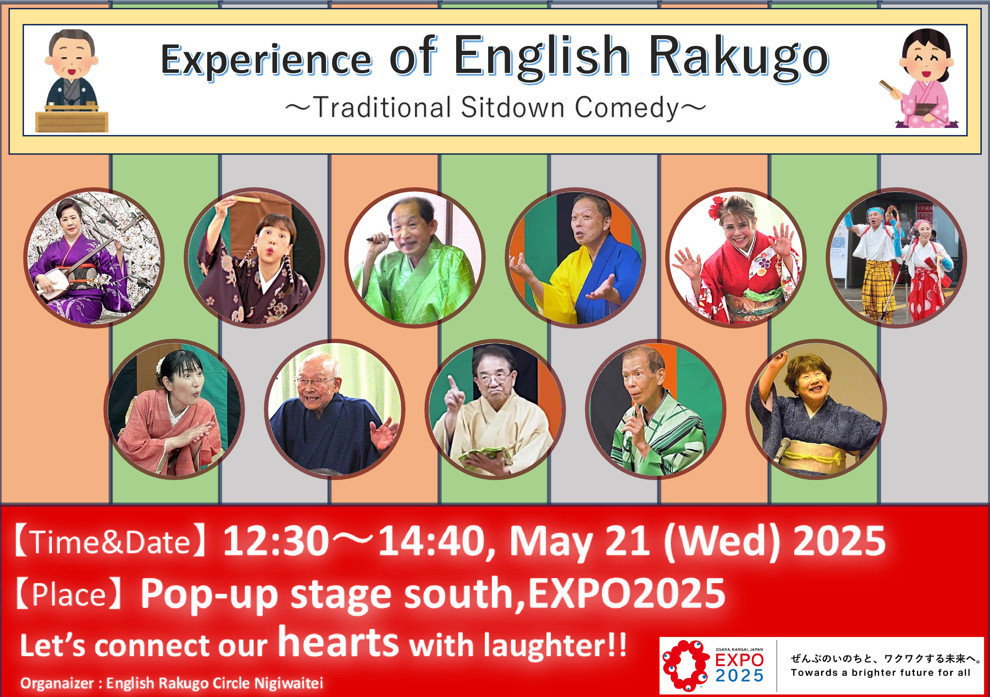



**Date**

**：**

**May 21(Wed), 2025**

**Time**

**：**

**Door opens 12:20, Show Starts 12:30, Ends 14:40**



～



Expo25 English



Rakugo



Program



～

Time

12:30

13:15

13:30

13:55

14:15

1.

What is

Rakugo

(

Showto

)

2.

Miso Beans (

Ryosho

)

3.

Ice Cream (Beauty Sato)

4.

Speaking Flowers (Yuen)

5.

I love Japan (Lina)

6.

Terrible Sushi (

Sayohime

)

7.

Shamisen Performance (Kaoru

Kiyama

)

①

Folk songs country tour

②

You are my

sunshine

～

Take

me home country roads

③

Tsugaru

Jongarabushi

8.

Young man and old man

（

Hassho

）

9.

In a museum (

Chamekichi

)

10.

Mt.

Atagoyama

(

)

Atom

11.

Workshop

–

Rakugo

experience (

Showto

)

12.

Nankin

Tamasudare

(

beaded hanging screen of bamboo

)

by

Rokumaru

&

Tsukushi

